1. Introduction

The main aim of our project named “HOT-SOFT JOBS.COM”, is to provide an opportunity for a user, i.e., a member to know the available jobs in the current Software Arena. And also to the employers to advertise the available jobs in their company, so that the persons who are interested in it, can contact.

Our project only provides the job details of the Software Industries, hence the name “SOFT”. The word “HOT”, because now a days, the software jobs are just like hot-cakes, whenever they are available, they are just emptied like that. And since it mainly deals with “JOBS” and it is an online database, the word “COM”. Hence our project is named “HOT-SOFT JOBS.COM”.

Hot-Soft Jobs.com allows users i.e, its members to upload resume, which can be viewed by an employer. A member can search the details of companies, through the links provided and can also have a view over the previous test papers of few companies, which may help them, before they face such campus tests in those companies. To become a member, all he need to do is just fill in the Registration form, and become a member. From that time, he can use our application, by just Logging in, by just entering the user-id and password.

2. Problem Definition

Our project named “HOT-SOFT JOBS.COM” is a online database like system, which allows to store the Resume of its members i.e. the persons who seeks only job through us (Of course, not for the employers).

They are mainly two persons who uses this, they are the persons who want to become an Employee, and the other is the Employer, who advertises his empty posts for jobs.

A person who likes to utilize (search for job not for employers) this site, should become a member of it. The membership can be obtained by filling the Registration form of Hot-Soft Jobs.com.

After he becomes a member, he will have his own unique id and a password, through which he can Login.

Once he Logs in, he will have many options like
- Creating/Updating Resume.
- Changing/Updating his profile.
- Searching the companies for jobs.

A employer doesn’t have any id’s. He can just enter the site as an employer and post the available jobs. He needs to describe the type of job, the pay package, company name and if necessary the address of it and so on. Also, he needs to give his contact information, so that the persons interested in it can contact them.

3. Literature Survey

The “Hot-Soft Jobs.com” is an internet job searching application. It is one of those top job searching sites, just like “naukri.com”, “Hot jobs.com” or “monster.com”.

These “naukri.com”, “Hot jobs.com” or “monster.com” are very top or highest or largely used sites for searching and viewing jobs for an employee who seeks jobs. They also provide for an employer to Post a Job, View the Resumes uploaded by the members of their sites.

They give opportunity for their members i.e. one who seeks job, to search jobs, upload or build resume. They will be intimated by them, whenever the category they have applied for the jobs, come in.

A user for these sites will have id and a password, to avoid misuse or confusion. This ensures that a person cannot represent another person, for which he may use that illegally and put the other person in problem.

We in our project “Hot – Soft Jobs.com”, provide member id’s and passwords for only users who want seeks job. This is to avoid mischievous by the persons who want pass time. The Main advantage or extra feature that we have provided in Hot-Soft Jobs is that, a job seeker can view the profiles or question papers of some of the software companies. This feature is not provided by any of the above mentioned top job searching sites.

The above mentioned top job searching sites take money from the “Employers” , for posting a job. They make these employers to create a member id for employers, which is separate. These employers need to fill in a form, and should pay to post a job on their sites.

In Hot-Soft Jobs.com, we doesn’t give risk for employers to create account. And there is no such rule like the employers should pay for the job they want to post. This keeps employers attracted, and to make our site no 1. We will have people called as administrators, who will maintain the databases. The requirement of these people is they should have some technical knowledge of how to directly query the databases. They need to check the database, and view the job postings. They need to confirm, what the employers has posted is true. If any false information is present, that will be deleted from the database from them. However this makes the site to have few persons to work for it. This will of course give jobs for few more pupils.

The one big difference of our site and the rest is that, every other top sites we see, is not specific. i.e. they display all the jobs, i.e. of all categories from agriculture to software and mechanical to electrical. But in our Site, we are strictly towards the software rather IT jobs. It includes both Software and Hardware technicians jobs, and for consultants and service jobs.

4. REQUIREMENT SPECIFICATION

The “Hot-Soft Jobs.com” is an internet application software that is useful in searching jobs in an internet. The requirements specification for the “Hot-Soft Jobs.com” is as described below.

FUNCTION:
Provide an opportunity to search the top software sites by the member and upload his resume which can be retrieved by the employer. And, also for the employer to post his job vacancies.

DESCRIPTION:
The person who likes to use for searching a job must become a member by registering himself. He will have a unique id and also a password. He can login, then can view/search the jobs and sample question papers. He can also upload his resume, so that it will be viewed by the employers.
The Employer can Post his job, and also can view the resumes and can call suitable persons if he likes.

INPUTS:
Inputs taken are details of the person when he becomes a member, like his name, address, contact number, email-id and so on. A member inputs his resume. Inputs like Job description are also taken by the employer.

OUTPUTS:
Outputs are based on the choice of the user, he needs to chose, like for member to search for job details and resume information. For employer, the details of the resumes of members i.e. the person who seeks for job.

PRE-CONDITION:
In order for a user to use the “Hot-Soft Jobs.com”, he needs to become a member.

POST-CONDITION:
Display messages such as the available Job details, account details, question papers of few companies, etc.

5. SYSTEM DESIGN

Here we are concerned with how the system functionality is to be provided by the different components of the system.Design deals with the actual path that is taken in order to execute the project i.e. the way it has been conceptualized according to the requirements.

Design is mainly divided into two parts, as
- Employee (Member) Part
- Employer Part

5.1 Data Flow Diagram

a> For Employers:

Enter
VIEW
RESUME
Job
Description
Database
Sample Question
Papers
SELECT
OPTIONS
POST
JOB

b> For Members:

New user
Member
Access Student
Details
Access Time Table
Details
Access System
Details
Enter
SAMPLE
PAPERS
VIEW
COMPANY
PROFILES
INTERVIEW
TIPS
REGISTER
Password
Database
Company
Database
Sample Question
Papers
LOGIN
SELECT
OPTIONS
Member
Database
Interview’s
Help
LOGOUT
Sign out

5.2 ER-Diagram for “Hot-Soft Jobs.com”:

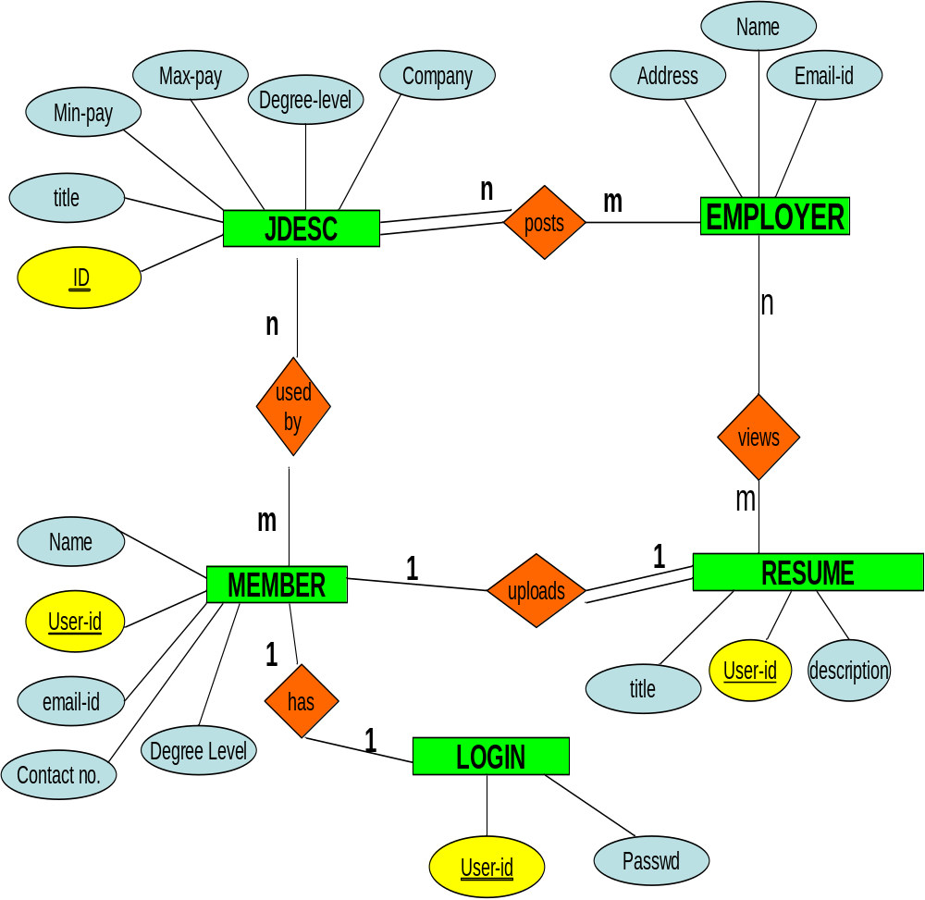

5.3 Database Design

The following tables are created in the database

- Login:

This table contains the Member information

- User-ID
- Password

Here User-ID is the primary key, and password must not be blank.

- Account:

This table contains the Employee information, such as

- User-ID
- First Name
- Middle Name
- Last Name
- Country
- Email-ID
- Employee Degree Level ID
- Career Level ID
- Total Work Experience

Here User-ID is the primary key, and First and Last Name, Email-ID, Password question and answer must not be blank.

- Jdesc:

This table contains the Job description, provided by the Employer.

- Name
- Company Name
- Email-ID
- Company Address
- Country
- Pin Code
- Phone Number
- Job Category
- City
- Job Title
- Job description
- Job Level
- Job Type
- Job Status
- Minimum Pay
- Maximum Pay

Here User-ID is the primary key, Email-ID and fields like company name, phone number and so on must not be blank.

- Resume:

This table contains the Resume Uploaded by the member.

- User-ID
- Title
- Resume Description

Here User-ID is the primary key, and Title and Description of the resume must be filled.

5.4 The Format of different tables used:

Login:
+--------+-------------+------+------+---------+-------+
| Field | Type | Null | Key | Default | Extra |
+--------+-------------+------+------+---------+-------+
| name | varchar(20) | | PRI | | |
| pass | varchar(20) | | | | |
+---------+-------------+------+-----+---------+-------+

Account:
+----------+-------------+------+-----+---------+-------+
| Field | Type | Null | Key | Default | Extra |
+----------+-------------+------+-----+---------+-------+
| uname | varchar(20) | YES | | NULL | |
| fname | varchar(30) | | | | |
| mname | varchar(30) | YES | | NULL | |
| lname | varchar(30) | | | | |
| cid | varchar(30) | YES | | NULL | |
| email | varchar(60) | | | | |
| passq | varchar(60) | YES | | NULL | |
| passa | varchar(20) | YES | | NULL | |
| elid | varchar(30) | YES | | NULL | |
| clid | varchar(50) | YES | | NULL | |
| degreeid | varchar(50) | YES | | NULL | |
+----------+-------------+------+-----+---------+-------+

Jdesc:

+---------+--------------+------+-----+---------+----------------+
| Field | Type | Null | Key | Default | Extra |
+---------+--------------+------+-----+---------+----------------+
| id | int(8) | | PRI | NULL | auto_increment |
| name | varchar(30) | YES | | NULL | |
| cname | varchar(30) | YES | | NULL | |
| email | varchar(60) | YES | | NULL | |
| caddr | varchar(60) | YES | | NULL | |
| country | varchar(30) | YES | | NULL | |
| pincode | varchar(20) | YES | | NULL | |
| phone | varchar(20) | YES | | NULL | |
| jcat | varchar(30) | YES | | NULL | |
| city | varchar(30) | YES | | NULL | |
| jtitle | varchar(70) | YES | | NULL | |
| jdesc | varchar(250) | YES | | NULL | |
| jlevel | varchar(30) | YES | | NULL | |
| jtype | varchar(25) | YES | | NULL | |
| jstatus | varchar(10) | YES | | NULL | |
| minpay | varchar(10) | YES | | NULL | |
| maxpay | varchar(10) | YES | | NULL | |
+---------+--------------+------+-----+---------+----------------+

Resume:
+-------+--------------+------+-----+---------+-------+
| Field | Type | Null | Key | Default | Extra |
+-------+--------------+------+-----+---------+-------+
| uname| varchar(20) | | | | |
| title | varchar(70) | | | | |
| rdesc | varchar(250)| YES | | NULL | |
+-------+--------------+------+-----+---------+-------+

5.5 Relation Schema:

Login:

User-ID | password

Here User-ID is the Primary Key, and password is another attribute.

Account:

User-ID | FirstName | MiddleName | LastName | Country | Email-ID
Employee Degree Level ID | Career Level ID | Total Work Experience

Here User-ID is the primary key, which is dereferenced to the Login table User-ID.

6. DETAILED DESIGN

The application is developed using CGI programming. The design of a CGI application is as follows. CGI is a lightweight interface. It is essentially the minimum that the web server needs to provide in order to allow external processes to create web pages. Typically when a web server gets a request for a static web page, the web server finds the corresponding HTML file on its file system.

When a web server gets a request for a CGI script, the web server executes the CGI script as another process. The server passes this process some parameters and collects its output, which it then returns to the client just as if had been fetched form a file.

Web browsers request dynamic information resources such as CGI scripts the same way they request any other resource on the web. They send a message formatted according to HTTP. The application contains HTML forms , which are user interfaces that provides input to CGI scripts. They are primarily used for two purposes : collecting data and accepting commands. For example , the data may include registration information, recipient information.

Pseudocode:

1>. The project starts with the main module i.e. the Home page.

Start HomePage.
If clicked=Login
Then
Go to login page
Else
if selected=Create_New_Account
then
go to Register form.
End
End
Finish

2>. Create New Account Form is to Register a user as a Member.

Start RegisterPage
If “All the required fields are filled” = true
Then
Update the database
Enter to MyHome Page
Else
Ask for required fields
End
Finish

3>. Login in as member.

Start LoginPage
If User=Member
then
if Password is correct
then
Go to MyHome Page
Else
Display invalid password
End
Else
Display invalid user
End
Finish

4>. MyHome Page of a Member

Start MyHomePage
If selected=SearchCompanyPapers
Then
Go to CompanyPage
Else if selected=UploadResume
Then
Go to ResumePage
Else if selected=EditAccount
Then
Go to EditAccountPage
End
Finish

5>. ResumePage

Start ResumePage
Enter the details.
If Resume=present
Then
Ask for deletion
If deletion=Yes
Then
Delete old resume
End
Else
Upload resume
End
Finish

6>. Employee Post a Job

Start PostJobPage
Fill in details
Submit
Finish

7>. Company Page for links to view or search sample test papers.

Start CompanyPage
If “the link of the required company”=true
Then
Go to corresponding company test papers page
End
Finish

8>. DeleteResumePage to delete the existing Resume.

Start DeleteResumePage
If Delete=Yes
Then
Delete the resume from database
End
Finish

9>. EditAccountPage to edit the details of the Member himself.

Start EditAccountPage
Edit the profile
If action=submit
Then
Update database

Else if action=cancel
Return to MyHomePage
End
Finish.

Site Map:

Hot-Soft Jobs.com -Home.html
Registration.html

Login.html
Employer.html

LinkCompanies.html
Resume.html
Profile.html

JobPost.html

Run-way of “Hot-Soft Jobs.com” as viewed by users.

7. Implementation

Login.cgi (To Check the whether the user is a member or not)

#!D:\Perl\bin\perl

use DBI();
use CGI;
$cg= new CGI();

print $cg->header();
print $cg->start_html;

$uname = $cg->param('USER');
#print $uname,"\n";
$dbh=DBI->connect("DBI:mysql:database=hotsoft;host=localhost","root","");
$sth=$dbh->prepare("SELECT pass FROM login WHERE NAME='$uname'");
$sth->execute();
if($sth->rows() > 0)
{
while($href=$sth->fetchrow_hashref())
{
if($pass ne $href->{'PASS'})
{
print $uname," : Invalid password.";
}
else
{
if(print("$uname: Successful login <br><p><br> Click here to <a href=http:\\\\localhost\\hot-soft\\myhome.html>My Home</a>") and open(FILE,"<..\..\..\Apache\htdocs\hot-soft\Home.html") )
{
print "HI";
while(<FILE>)
{
print $_;
}
}
close(FILE);
# print "Success full login";
}
}
}
else
{
print "Invalid User-id";
}

print $cg->end_html;
$sth->finish();
$dbh->disconnect();

exit(0);

___________________________________________________________________

Register.cgi (To Register a new user as a member of Hot-Soft Jobs.com)

#!D:\Perl\bin\perl

print "Content-type: text/html","\n\n";

$req_method = $ENV{'REQUEST_METHOD'};

if($req_method eq "GET")
{
$que_str = $ENV{'QUERY_STRING'};
}
elsif($req_method eq "POST")
{
read(STDIN,$que_str,$ENV{'CONTENT_LENGTH'});
}
else
{
print "Error : \n";
exit(1);
}

@key_value_pairs = split(/&/,$que_str);

foreach $key_value (@key_value_pairs)
{
($key,$value) = split(/=/,$key_value);
$value =~ tr/+/ /;
$value =~ s/%([\dA-Fa-f][\dA-Fa-f])/pack ("C",hex ($1))/eg;
if ($key eq "uname") {$uname = $value;}
if ($key eq "fname") {$fname = $value;}
if ($key eq "lname") {$lname = $value;}
if ($key eq "mname") {$mname = $value;}
if ($key eq "cid") {$cid = $value;}
if ($key eq "email") {$email = $value;}
if ($key eq "passq") {$passq = $value;}
if ($key eq "passa") {$passa = $value;}
if ($key eq "elid") {$elid = $value;}
if ($key eq "clid") {$clid = $value;}
if ($key eq "degreeid") {$degreeid = $value;}
if ($key eq "pass") {$pass = $value;}
}

print "Hello: ";
print $uname;
use DBI();

my $dbh = DBI->connect("DBI:mysql:database=hotsoft","root","");
$query_statement = "select * from login where name='$uname'";
my $sth = $dbh->prepare($query_statement);
$sth->execute();

if ($ref = $sth->fetchrow_hashref())
{
if($ref->{name} eq $uname )
{
print "\n$uname already exits.","\n";
print "\nTry other User Names.\n";
exit(0);
}
}
else
{
$dbh->do("insert into login(name,pass) values ('$uname','$pass')") or die("Cannot insert to login");
}

$query_str = "insert into account(uname,fname,mname,lname,cid,email,passq,passa,elid,clid,degreeid) values ('$uname','$fname','$mname','$lname','$cid','$email','$passq','$passa','$elid','$clid','$degreeid') ";

$dbh->do($query_str) or die("Cannot insert to account table");

print <<'EOF';

<html>

<head>
<!--meta http-equiv="Content-Language" content="en-us">
<meta name="GENERATOR" content="Microsoft FrontPage 5.0">
<meta name="ProgId" content="FrontPage.Editor.Document">
<meta http-equiv="Content-Type" content="text/html; charset=windows-1252"-->
<title> Successful Member of Hot-Soft </title>
</head>

<body>

<p>&nbsp;&nbsp;&nbsp;&nbsp;
<img border="0" src="http://localhost/cgi-bin/hot-soft/hotsoft.gif" width="534" height="132"></p>
<p>
<IMG height=15 src="http://localhost/cgi-bin/hot-soft/festive_head.gif"
width=701></p>
<P><STRONG><FONT face="Verdana, Arial, Helvetica, sans-serif"
size=4>Hot-Soft Jobs</FONT></STRONG><FONT
face="Verdana, Arial, Helvetica, sans-serif" size=4><STRONG>
Works...for you.</STRONG></FONT><BR><FONT
face="Verdana, Arial, Helvetica, sans-serif" size=1>Whatever you're
looking for in a Software job, Hot-Soft Jobs.com can help you find
it.<BR><B>As only India's No.1 Job Site can!</B></FONT></P>
<P><B><FONT face="Verdana, Arial, Helvetica, sans-serif" size=2>You
have Successfully registered yourself with Hot-Soft
Jobs.com</FONT></B></P>
<P><FONT face="Verdana, Arial, Helvetica, sans-serif" size=2><A
href="http://localhost/cgi-bin/hot-soft/Login.html">Click here to
login</A></FONT></P>
<P>
<img border="0" src="http://localhost/cgi-bin/hot-soft/festive_tail.gif" width="720" height="66"></P>
<P>&nbsp;</P>
<P>&nbsp;</P>
<P>&nbsp;</P>

</body>

</html>

<!--font size=6 color=blue family=tahoma><u>You are now a member of </font> <h1><b><font size=10 color=green>Hot - Soft Jobs . com </font></b></h1></u-->";
EOF

exit(0);

___________________________________________________________________

Resume.cgi (For a member to Upload his Resume)

#!D:\Perl\bin\perl

use CGI;
use DBI;

$cg = new CGI();
print $cg->header();
print $cg->start_html;

$uname = $cg->param('uname');

my $db = DBI->connect("DBI:mysql:database=hotsoft","root","");
my $sth = $db->prepare("select * from resume where uname='$uname'");
$sth->execute();
my $h = $sth->fetchrow_hashref();

print "$uname: ";

if ($sth->rows())
{
print<<'EOF';
<font size=5 color=red family=verdana><p><h2> Your resume already exits </h2></font>
<p><FORM ACTION=http://localhost/cgi-bin/hot-soft/delresume.cgi?uname=$uname METHOD=POST>
Delete old Resume: <INPUT TYPE = SUBMIT value="Yes ?" name=delete>
EOF
}
else
{
$des = $cg->param('des');
$title = $cg->param('title');
$db->do("insert into resume(uname,title,rdesc) values ('$uname','$title','$des')");
print "$uname: Your Resume has been successfully Uploaded<p>";
print "Return to <a href=http://localhost/hot-soft/myhome.html> My Home </a>";
}
print $cg->end_html;

$sth->finish();
$db->disconnect();

exit(0);

___________________________________________________________________

Delresume.cgi (To delete the existing Resume)

#!D:\Perl\bin\perl

use CGI;
use DBI;

$cg = new CGI();
print $cg->header();
print $cg->start_html;

$uname = $cg->param('uname');

my $db = DBI->connect("DBI:mysql:database=hotsoft","root","");
$db->do("delete from resume where uname='$uname'");

print <<'EOF';
$uname: Your old Resume has been deleted.
<p>If you want create a new resume click <a href=http://localhost/hot-soft/resume.html> Here </a>
<p> Click here<a href=http://localhost/hot-soft/Home.html> Home page</a>
EOF

print $cg->end_html;

$db->disconnect();

exit(0);

___________________________________________________________________

JobPost.cgi: (For the Employer to post a Job)

#!D:\Perl\bin\perl

use DBI;
use CGI;

$cgi = new CGI();

print $cgi->header();
print $cgi->start_html;

$jcat = $cgi->param('jcat');
$city = $cgi->param('city');
$jtitle = $cgi->param('jtitle');
$jdesc = $cgi->param('jdesc');
$jlevel = $cgi->param('jlevel');
$jtype = $cgi->param('jtype');
$jstatus = $cgi->param('jstatus');
$minpay = $cgi->param('minpay');
$maxpay = $cgi->param('maxpay');

$name = $cgi->param('name');
$cname = $cgi->param('cname');
$email = $cgi->param('email');
$caddr = $cgi->param('caddr');
$country = $cgi->param('country');
$pincode = $cgi->param('pincode');
$phone = $cgi->param('phone');

my $dbh = DBI->connect("DBI:mysql:database=hotsoft","root","");
$dbh->do("insert into jdesc(jcat,city,jtitle,jdesc,jlevel,jtype,jstatus,minpay,maxpay,name,cname,email,caddr,country,pincode,phone) values ('$jcat','$city','$jtitle','$jdesc','$jlevel','$jtype','$jstatus','$minpay','$maxpay','$name','$cname','$email','$caddr','$country','$pincode','$phone')");

print <<'EOF';
<a href=http://localhost/hot-soft/Home.html> Here </a>
EOF

$dbh->disconnect();
print $cgi->end_html;

exit(0);

___________________________________________________________________

passchange.cgi: (To change Password for members)

#!D:/perl/bin/perl

use DBI;
use CGI;

$cgi = new CGI();

print $cgi->header();
print $cgi->start_html;

$query_str = $ENV->{'QUERY_STRING'};
$uname = $cgi->param('uname');
$pass = $cgi->param('pass');

$db = DBI->connect("DBI:mysql:database=hotsoft","root","");
$db->do("UPDATE LOGIN SET PASS=$pass WHERE NAME='$uname'");

print <<'EOF';
<p><br>Your Password has been changed.
<p><br>Click here for <a href=http://localhost/hot-soft/myhome.html>MyHome</a>
EOF

exit(0);

___________________________________________________________________

adminlog.cgi: (For the Administrators of Hot-Soft Jobs.com)

#!D:/perl/bin/perl

use CGI;
use DBI;

$cg = new CGI();

$uname = $cg->param('adminname');
$pass = $cg->param('adminpass');

print $cg->header();
print $cg->start_html;

$db = DBI->connect("DBI:mysql:database=hotsoft","root","");
$st = $db->prepare("SELECT * FROM ADMIN WHERE NAME='$uname'");
$st->execute();

if($st->rows() <= 0)
{
print "Invalid Administrator.\n";
print "Please try Again.";
}
else
{
$hr = $st->fetchrow_hashref();
if ($hr->{'pass'} eq $pass)
{
print "<h1>Welcome Administrator: $uname.</h1>";
$path_html = "../../htdocs/hot-soft/AdminHome.html";
open(FILE,"< $path_html");#or die("Cannot open file AdminHome.html");
while(<FILE>)
{
print $_;
}
}
else
{
print "Invalid password.";
}
}

print $cg->end_html;

$st->finish();
$db->disconnect();

exit(0);

___________________________________________________________________

choice.cgi: (Depending on Administrators choice display the information like view members, job postings and employers information.)

#!D:/perl/bin/perl

use DBI;
use CGI;

$cgi = new CGI();

print $cgi->header();
print $cgi->start_html;

$choice = $cgi->param('choice');
$db = DBI->connect("DBI:mysql:database=hotsoft","root","");
$sth = $db->prepare("SELECT * FROM JDESC");

if ($choice == 1)
{
$sth = $db->prepare("SELECT * FROM LOGIN");
$sth->execute();
if($sth->rows()>0){
print "<align=center><font size=6>User in the database.</font>";
$h = $sth->fetchrow_hashref();
while($h)
{
print "<hr><p><p>User Name: $h->{'name'}<br>";
$h = $sth->fetchrow_hashref();
}
}
}
elsif($choice == 2)
{
$sth->execute();
if($sth->rows()>0){
print "<align=center><font size=6>Employers in the database.</font>";
$h = $sth->fetchrow_hashref();
while($h)
{
print "<hr><p><p>User Name: $h->{'name'} \t";
print "E-mail : $h->{'email'}<br><hr>";
$h = $sth->fetchrow_hashref();
}
}
}
elsif($choice == 3)
{
$sth->execute();
if($sth->rows()>0){
print "<align=center><font size=6>Jobs in the database.</font>";
$h = $sth->fetchrow_hashref();
while($h)
{
print "<hr><p><p>Job ID: $h->{'id'}<br>Job Title: $h->{'jtitle'}<br>";
print "\t Company: $h->{'cname'}<br><hr>";
$h = $sth->fetchrow_hashref();
}
}
}

print "<form action=http://localhost/cgi-bin/hot-soft/admingetinfo.cgi?choice=$choice method=post>";
print <<'EOF';
Enter the Name/ID(for jobs) you want to see details : <input type=textbox name=tname>
<input type=submit value=Go!!!>
</form>
<p><br>Click here for <a href=http://localhost/hot-soft/adminhome.html> Admin Home </a>
EOF

$sth->finish();
$db->disconnect();
print $cgi->end_html;

exit(0);

___________________________________________________________________

admingetinfo.cgi: (Depending on Administrators choice: view members, job postings and employers information will be displayed.)

#!D:/perl/bin/perl

use DBI;
use CGI;

$cgi = new CGI();

print $cgi->header();
print $cgi->start_html;

$query_str = $ENV{'QUERY_STRING'};

($ch,$choice) = split(/=/,$query_str);

$tname = $cgi->param('tname');

$db = DBI->connect("DBI:mysql:database=hotsoft","root","");
$sth = $db->prepare("SELECT * FROM JDESC WHERE NAME='$tname'");

if ($choice == 1)
{
$sth = $db->prepare("SELECT * FROM ACCOUNT WHERE UNAME='$tname'");
$sth->execute();
if($sth->rows()>0){
print "<align=center><font size=6>$tname 's details in the database.</font>";
$h = $sth->fetchrow_hashref();
print "<p><p><hr><center>First Name: $h->{'fname'}<br>Middle Name: $h->{'mname'}<br>Last Name: $h->{'lname'}<br>Country: $h->{'cid'}<br> Email: $h->{'email'}<br> <p>Total Work Experience: $h->{'elid'}<br> Careel Level: $h->{'clid'}<br>Degree/Level Attained: $h->{'degreeid'}<br>";
}
else
{
print "<font size=5 face=verdena color=red> Nothing to display for this ' $tname ' </font>";
}
}
elsif($choice == 2)
{
$sth->execute();
if($h = $sth->fetchrow_hashref())
{
print "<align=center><font size=6>Employers in the database.</font>";
print "<center><p><br>Name:\t = $h->{'name'}";
print "<br>Company Name:\t = $h->{'cname'}";
print "<br>Email-ID:\t = $h->{'email'}";
print "<br>Company Address:\t = $h->{'caddr'}";
print "<br>Country:\t = $h->{'country'}";
print "<br>Pin code:\t = $h->{'pincode'}";
print "<br>Phone Number:\t = $h->{'phone'}</center>";
}
else
{
print "<font size=5 face=verdena color=red> Nothing to display for this ' $tname ' </font>";
}
}
elsif($choice == 3)
{
$sth = $db->prepare("SELECT * FROM JDESC WHERE ID='$tname'");
$sth->execute();
if($h = $sth->fetchrow_hashref())
{
print "<font size=6>Jobs in the database.</font><br><p><p><hr>";
print "<center>Job Title : $h->{'jtitle'}<br>";
print "Job Category : $h->{'jcat'}<br>";
print "Job Description : $h->{'jdesc'}<br>";
print "Job Level : $h->{'jlevel'}<br>";
print "Job Status : $h->{'jstatus'}<br>";
print "City : $h->{'city'}<br>";
print "Job Type : $h->{'jtype'}<br>";
print "Maximum Pay : $h->{'maxpay'}<br>";
print "Minimum Pay : $h->{'minpay'}<br></align><hr></center>";
}
else
{
print "<font size=5 face=verdena color=red> Nothing to display for this ' $tname ' </font>";
}
}

$sth->finish();
$db->disconnect();
print $cgi->end_html;

exit(0);

8. Testing

Case | Expected Result | Actual Result
Try to login with invalid username and/or password | Login should fail | A message was displayed stating that login failed & prompted the user to log in again
While Registering as a member, if the passwords (i.e. current and confirm passwords) doesn’t match. | Registering as must fail | A message should displayed stating that passwords does not match.
While changing the password, if the passwords (i.e. old and new passwords) doesn’t match. | Password Change should not be done. | A message stating passwords does not match should be displayed.
After editing the account, if the password entered for saving the changes does not match. | The changes should not be updated. | An alert of password is invalid should be displayed

9. Conclusion

“Hot-Soft Jobs.com” project is tested extensively and has shown robust performance. From random reports of various test, response has been quite satisfactory. Valued suggestions are being considered.

We also have gained knowledge while working on this project. Most of the topics were very interesting like connecting Mysql with Perl/CGI script. The displaying of Dynamic forms and also reading the HTML files were like enjoying a game. The invaluable experience gained will help in a long way to make further versions of project a better product.

We have incorporated all the necessary features and tried to make it as error free as possible. The code is written in a way that is reversible and understandable. It can in future be extended to have a person who maintains all the databases and check the job posts and so on.

10. Future Enhancements

The project has been developed keeping in mind any future enhancements to the project, as it is open source code product.

This project can be extended to much more sophisticated internet application software, where a person or a group of persons, can make changes to database like deleting the old jobs, which were posted. The team can also check for the correctness of the Job Posts.

This can be made corporate, where an organization can collect money for registering a member, and also from employers, when they post job.

11. Applications

The Hot-Soft Jobs.com can be used by any organization with a very little modification (if needed) and can be used in their companies to display the job post a available and to have the employees for their company.

The Entire “Hot-Soft Jobs.com” can be owned by a single organization or any other setups, and can obtain the money, by providing the space for advertisements for companies and also from members, when they register.

This can also be used to explain students, how the CGI scripts, HTML forms and databases is used to develop the Internet applications like financing, searching jobs, banking and many other transactions, which occur through internet.

12. Appendix

SAMPLE SNAPSHOTS

1>. Home Page:

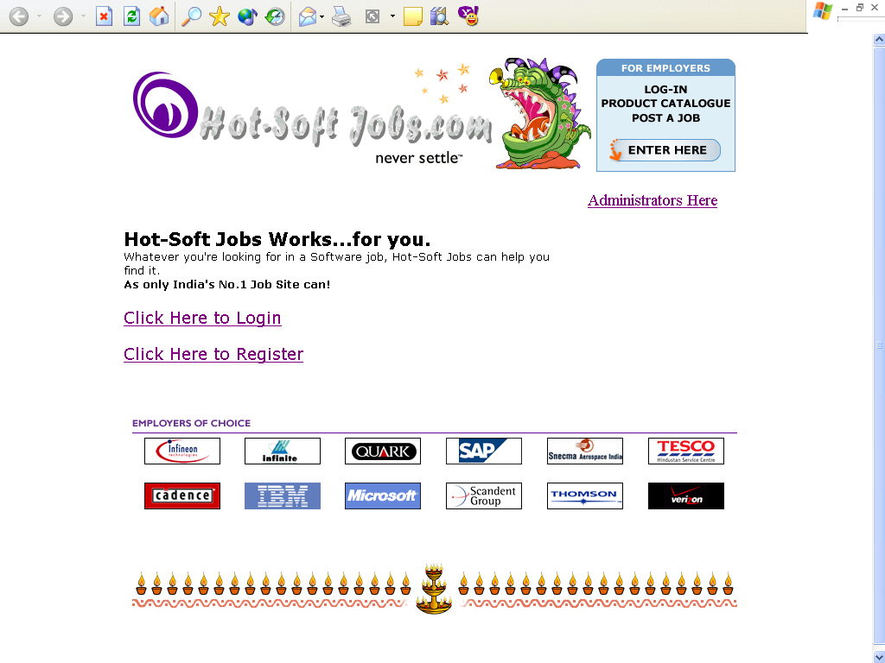

This is the Home page of the Hot-Soft Jobs.com. A user can go Login page or Register Page from here.

It also contains links to Administrator Login and Employers job postings forms.

Sample Input:

2>. Register Form:

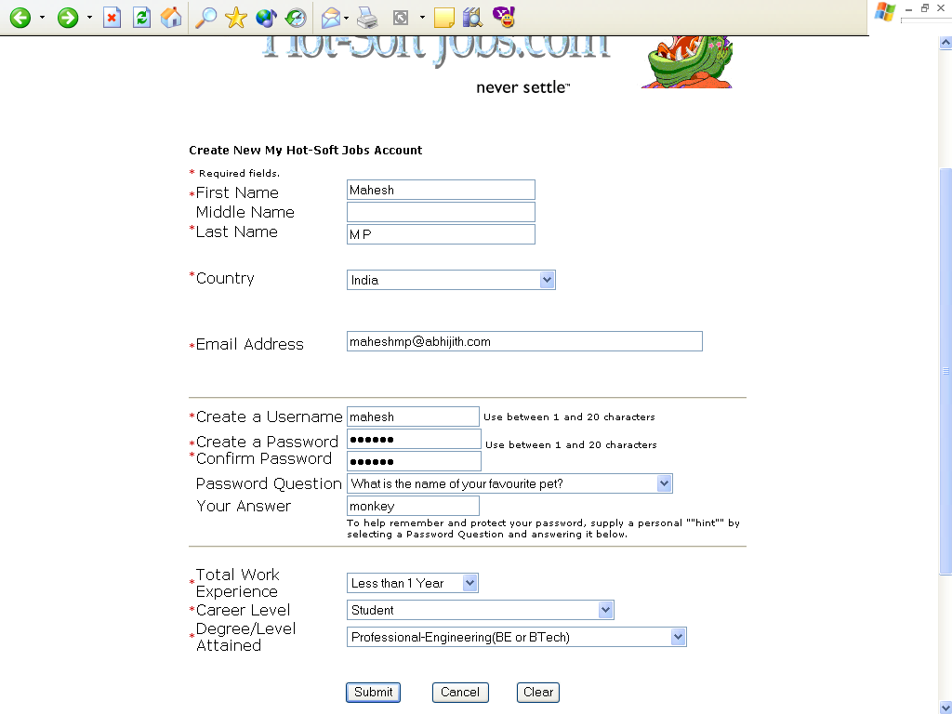

A person can become member by filling in the details of the form and pressing submit button. From then on, he becomes a member of the Hot-Soft Jobs.com.

3>. Uploading Resume:

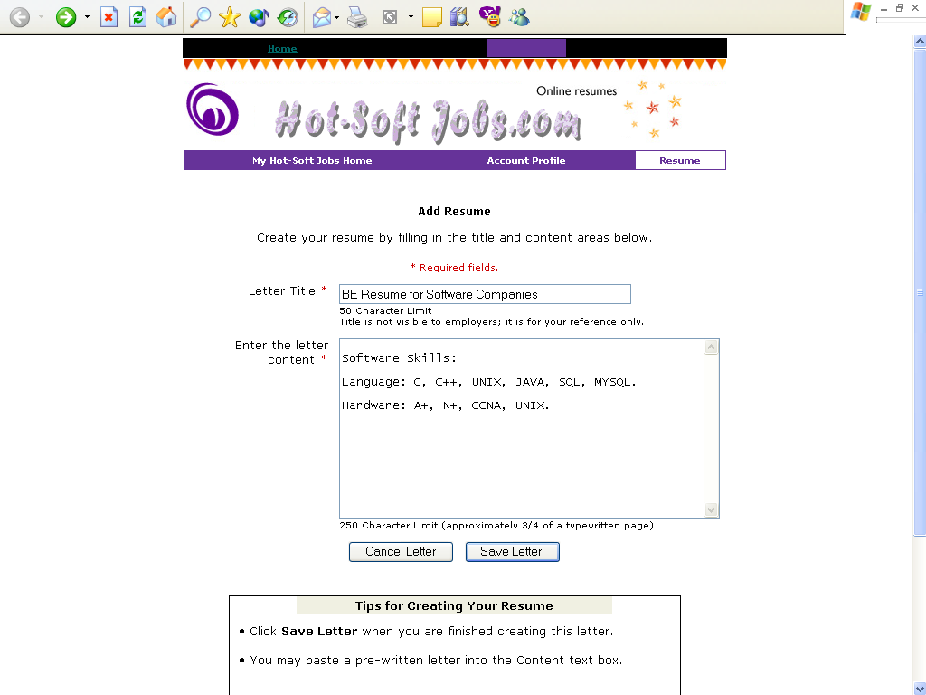

In this form, you can fill the title and the Description of the resume. You will get the response after pressing the submit button like resume updation or deletion confirmation of the old one.

4>. Admin Login:

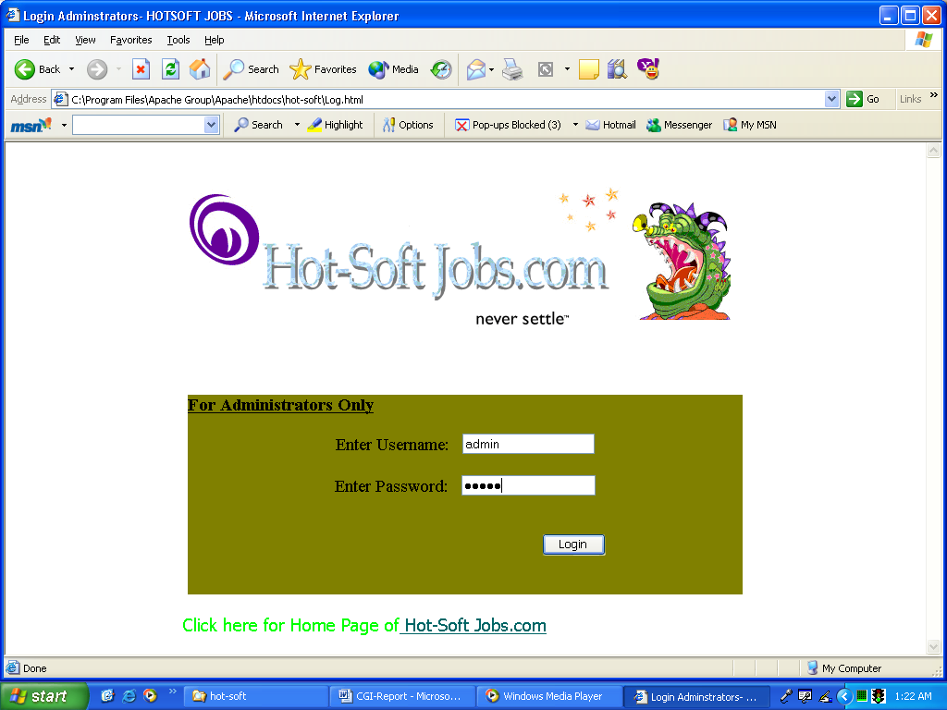

Here administrator id will be validated and allowed to enter the site.

5>. Administrator Home:

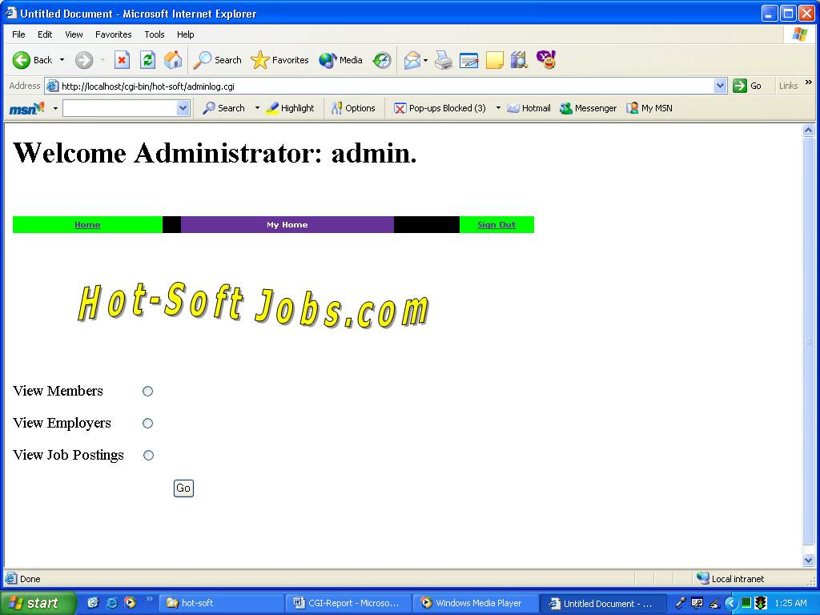

This is an administrator option selection form. Here he can view members, employers and job postings. He can also view the specific information of these.

Sample Output:

6>.Response when a person becomes a member.

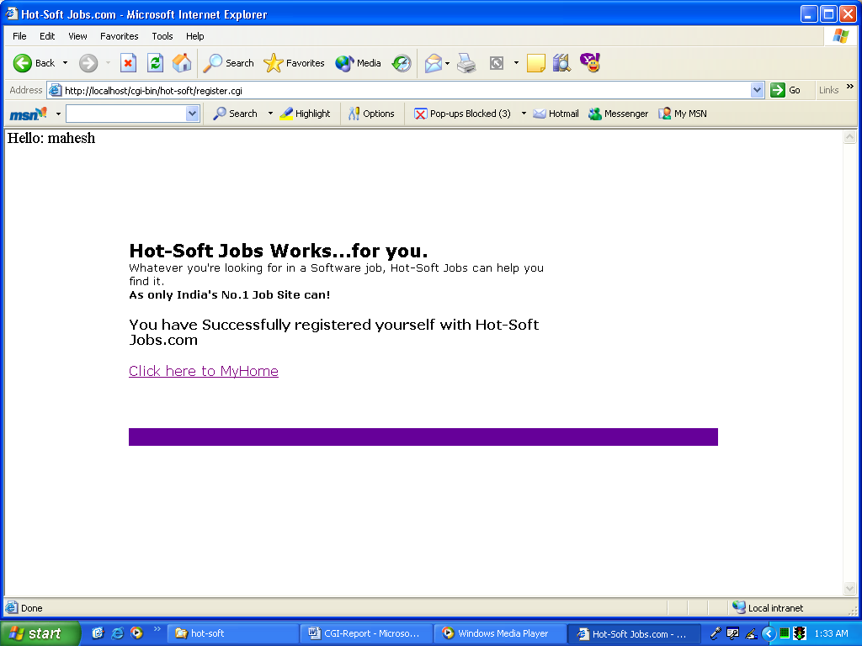

7>.Case when a user name already exits.

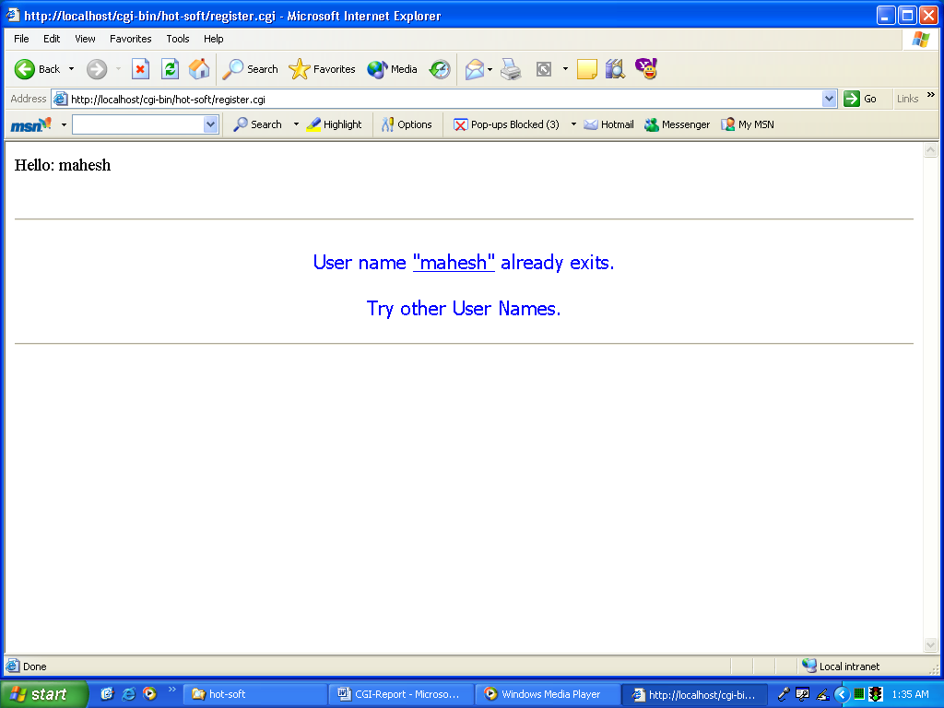

8>.Confirmation of Deletion of Resume.

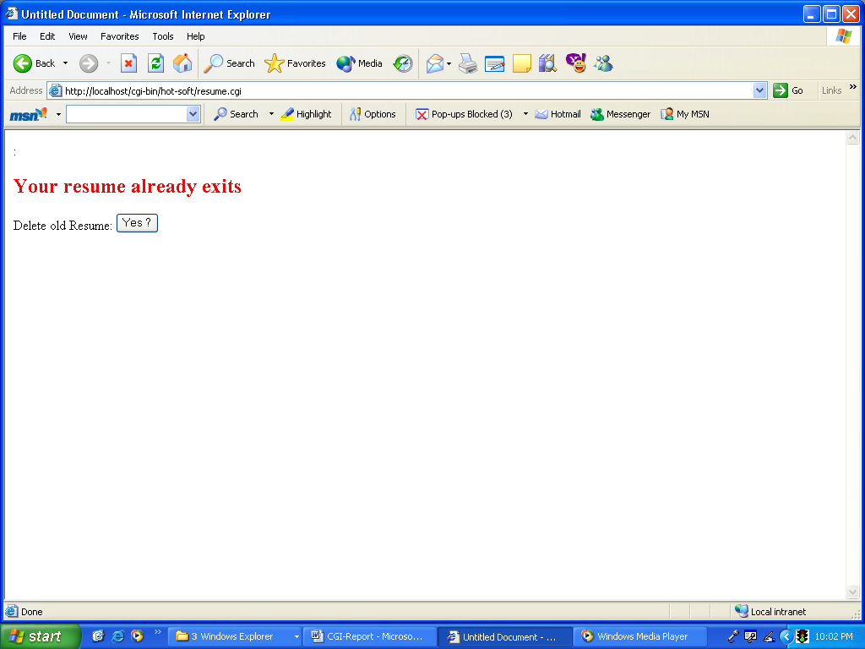

If the Resume already exits, then a message of whether the resume should be deleted, is asked to the user.

9>. Resume Updation Success message.

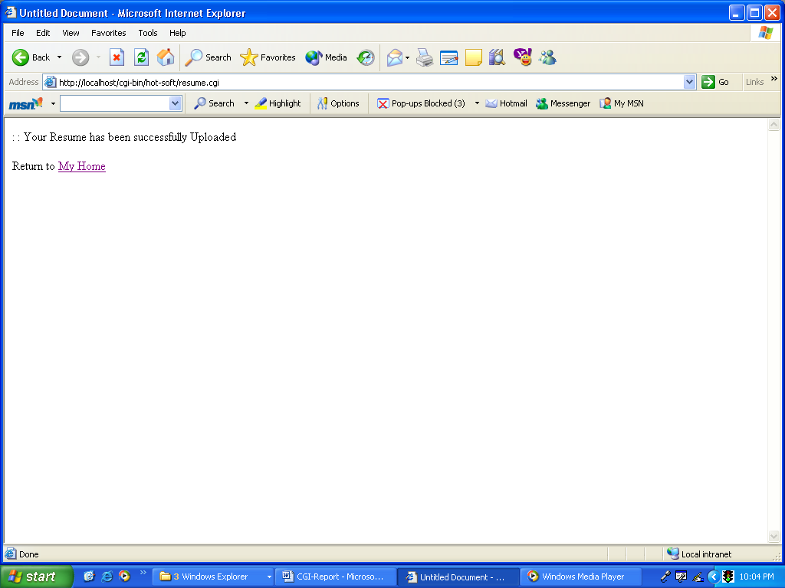

If no Resume is there, then the Resume is uploaded, and the message is displayed.

10>.View Members:

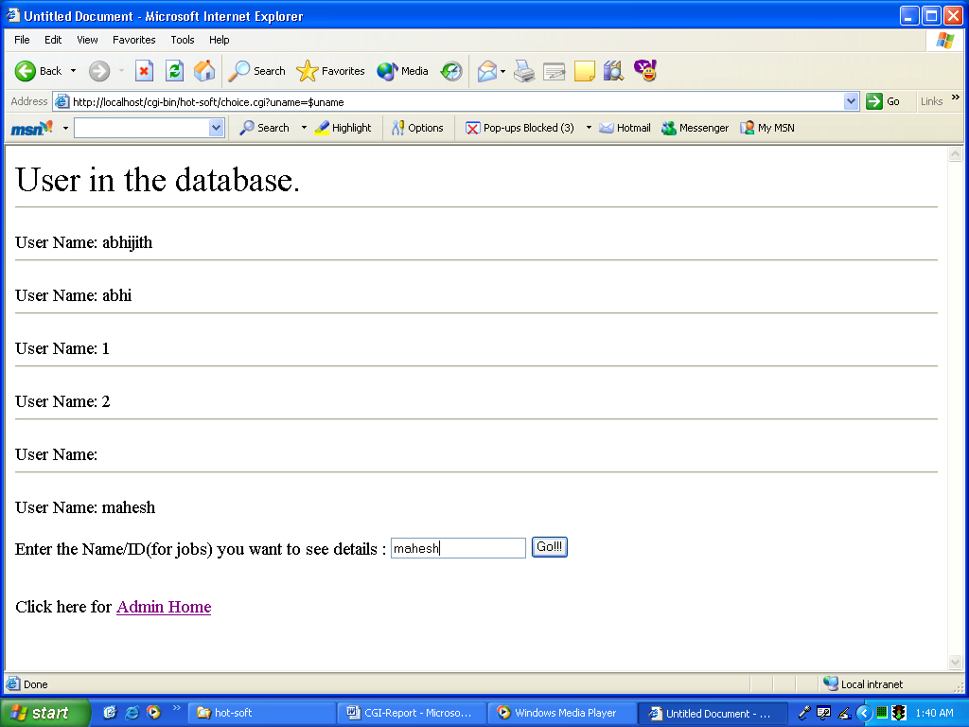

When an administrator selects the option to view the members in the database, the user names are displayed. If he enter’s the name in the text box, he can view the specific details of them.

11>. View specific Information of a member:

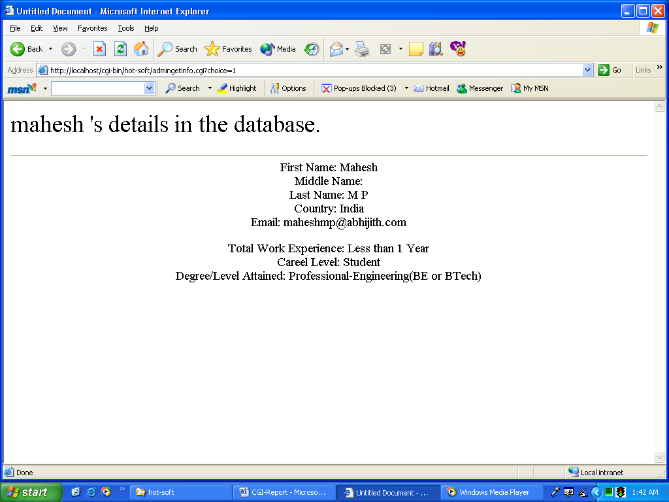

A member details will be displayed like his first name, country, graduation level and so on.

12>. Employers in database:

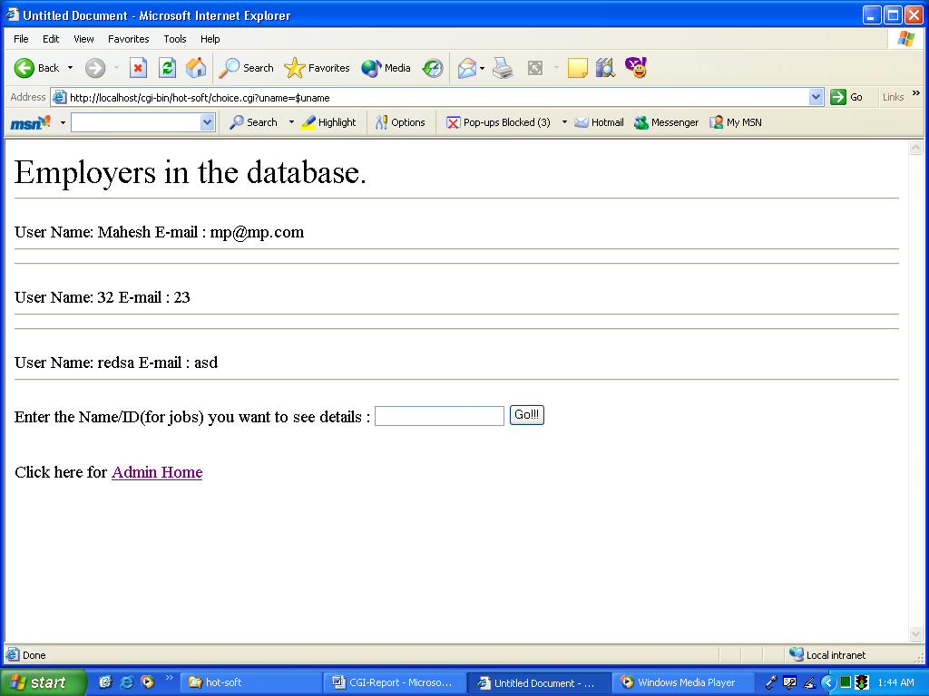

13>. Jobs in database:

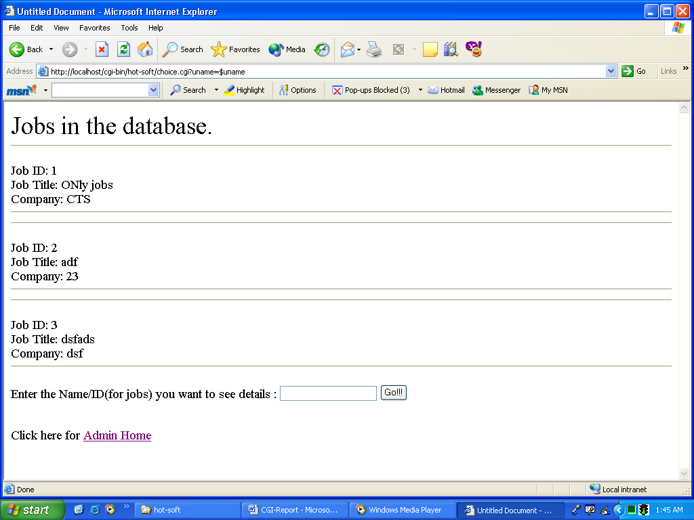

13. Bibliography

- CGI Programming on the World Wide Web - Shishir Gundavaram.

- PERL MAN pages in Linux OS.

- HTML Complete Reference - BPB Publications.

- Concepts from Naukri, Hot Jobs and Monster sites.

